**Worksheet-3.3**

**Student Name:-** Pushpraj Roy **UID:-** 20BCS9866

**Branch:-** BE- CSE **Section/Group:-** WM_617 “A”

**Subjetct Code:-** 20CSP-317 **Semester:-** 5th

**Subject Name:-** Machine Learning Lab

1. **Aim/Overview of the practical:-**

Implement Association Rule Mining.

1. **Task to be done/ Which logistics used:-**

Implement Association Rule mining

1. **Steps for experiment/practical/Code:-**

**# Implement Association Rule Mining.**

**data = [**

**['T100',['I1','I2','I5']],**

**['T200',['I2','I4']],**

**['T300',['I2','I3']],**

**['T400',['I1','I2','I4']],**

**['T500',['I1','I3']],**

**['T600',['I2','I3']],**

**['T700',['I1','I3']],**

**['T800',['I1','I2','I3','I5']],**

**['T900',['I1','I2','I3']]**

**]**

**init = []**

**for i in data:**

**for q in i[1]:**

**if(q not in init):**

**init.append(q)**

**init = sorted(init)**

**print(init)**

**sp = 0.4**

**s = int(sp*len(init))**

**s**

**from collections import Counter**

**c = Counter()**

**for i in init:**

**for d in data:**

**if(i in d[1]):**

**c[i]+=1**

**print("C1:")**

**for i in c:**

**print(str([i])+": "+str(c[i]))**

**print()**

**l = Counter()**

**for i in c:**

**if(c[i] >= s):**

**l[frozenset([i])]+=c[i]**

**print("L1:")**

**for i in l:**

**print(str(list(i))+": "+str(l[i]))**

**print()**

**pl = l**

**pos = 1**

**for count in range (2,1000):**

**nc = set()**

**temp = list(l)**

**for i in range(0,len(temp)):**

**for j in range(i+1,len(temp)):**

**t = temp[i].union(temp[j])**

**if(len(t) == count):**

**nc.add(temp[i].union(temp[j]))**

**nc = list(nc)**

**c = Counter()**

**for i in nc:**

**c[i] = 0**

**for q in data:**

**temp = set(q[1])**

**if(i.issubset(temp)):**

**c[i]+=1**

**print("C"+str(count)+":")**

**for i in c:**

**print(str(list(i))+": "+str(c[i]))**

**print()**

**l = Counter()**

**for i in c:**

**if(c[i] >= s):**

**l[i]+=c[i]**

**print("L"+str(count)+":")**

**for i in l:**

**print(str(list(i))+": "+str(l[i]))**

**print()**

**if(len(l) == 0):**

**break**

**pl = l**

**pos = count**

**print("Result: ")**

**print("L"+str(pos)+":")**

**for i in pl:**

**print(str(list(i))+": "+str(pl[i]))**

**print()**

**from itertools import combinations**

**for l in pl:**

**c = [frozenset(q) for q in combinations(l,len(l)-1)]**

**mmax = 0**

**for a in c:**

**b = l-a**

**ab = l**

**sab = 0**

**sa = 0**

**sb = 0**

**for q in data:**

**temp = set(q[1])**

**if(a.issubset(temp)):**

**sa+=1**

**if(b.issubset(temp)):**

**sb+=1**

**if(ab.issubset(temp)):**

**sab+=1**

**temp = sab/sa*100**

**if(temp > mmax):**

**mmax = temp**

**temp = sab/sb*100**

**if(temp > mmax):**

**mmax = temp**

**print(str(list(a))+" -> "+str(list(b))+" = "+str(sab/sa*100)+"%")**

**print(str(list(b))+" -> "+str(list(a))+" = "+str(sab/sb*100)+"%")**

**curr = 1**

**print("choosing:", end=' ')**

**for a in c:**

**b = l-a**

**ab = l**

**sab = 0**

**sa = 0**

**sb = 0**

**for q in data:**

**temp = set(q[1])**

**if(a.issubset(temp)):**

**sa+=1**

**if(b.issubset(temp)):**

**sb+=1**

**if(ab.issubset(temp)):**

**sab+=1**

**temp = sab/sa*100**

**if(temp == mmax):**

**print(curr, end = ' ')**

**curr += 1**

**temp = sab/sb*100**

**if(temp == mmax):**

**print(curr, end = ' ')**

**curr += 1**

**print()**

**print()**

1. **Result/Output/Writing Summary:-**

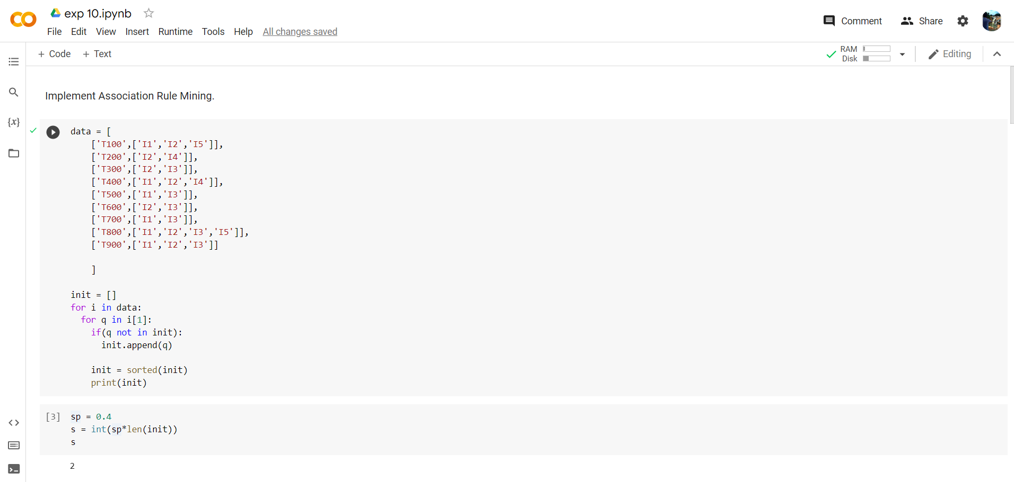

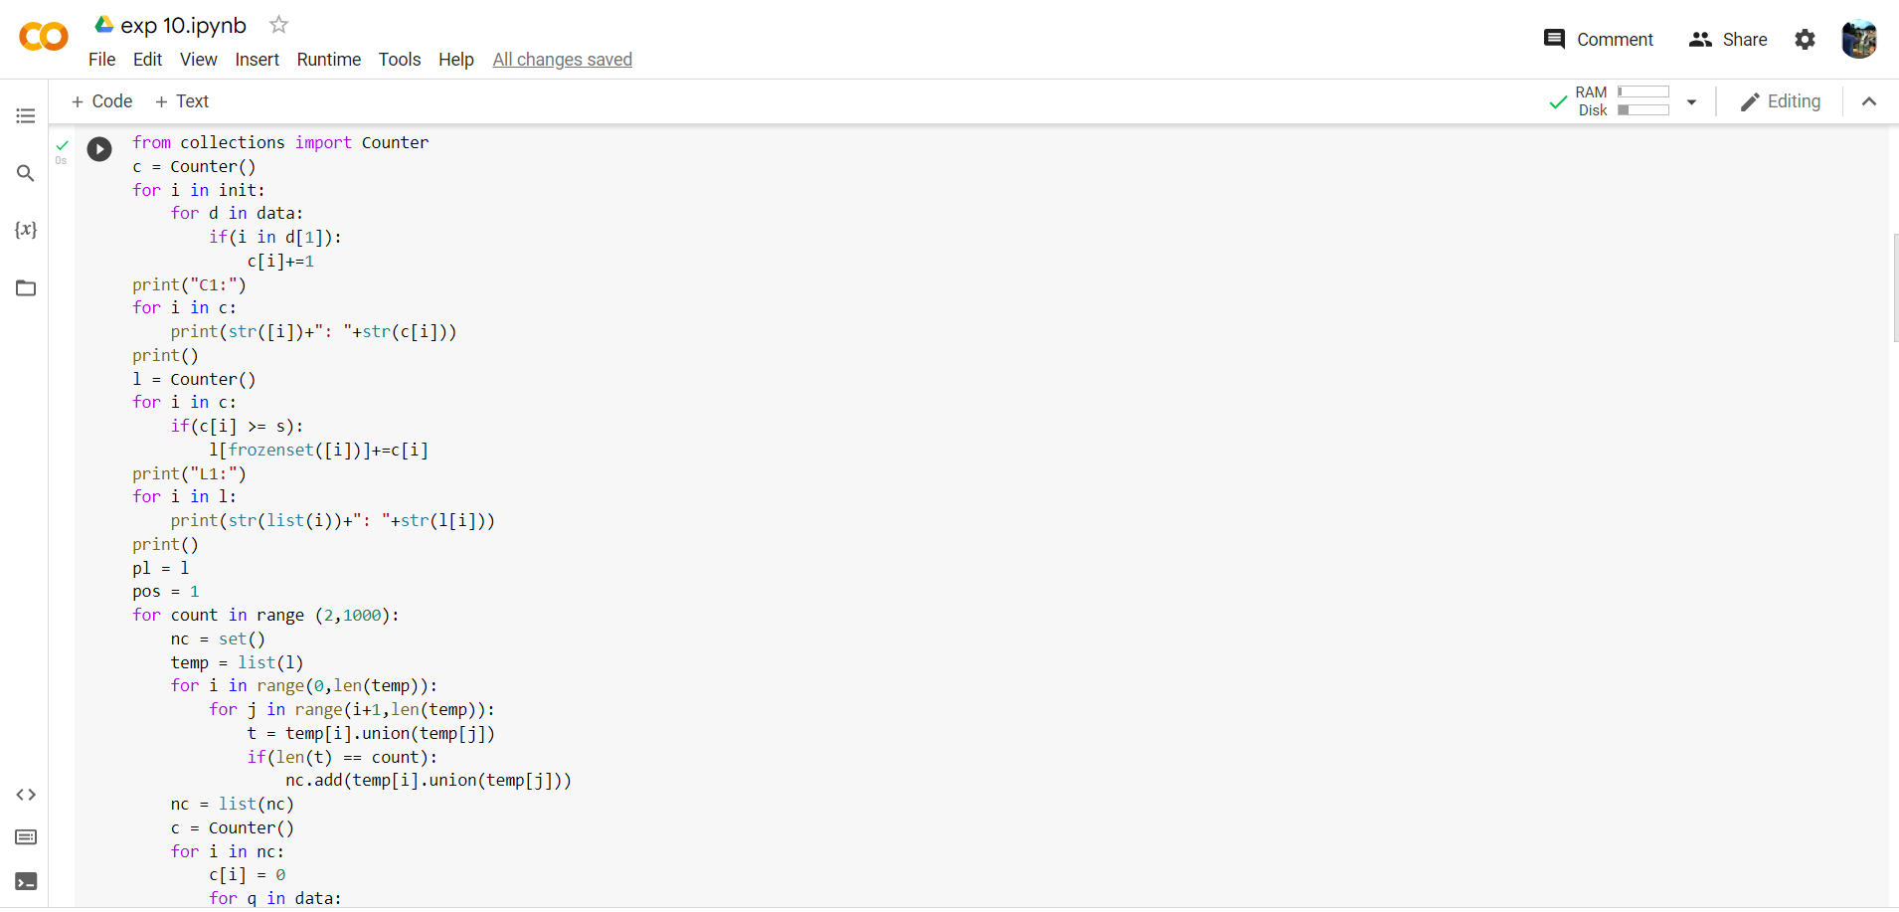

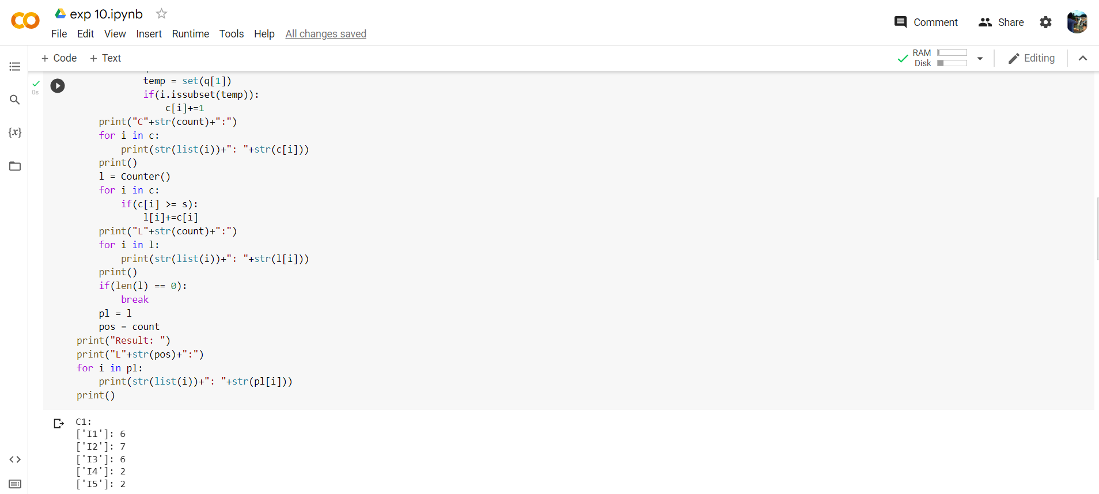

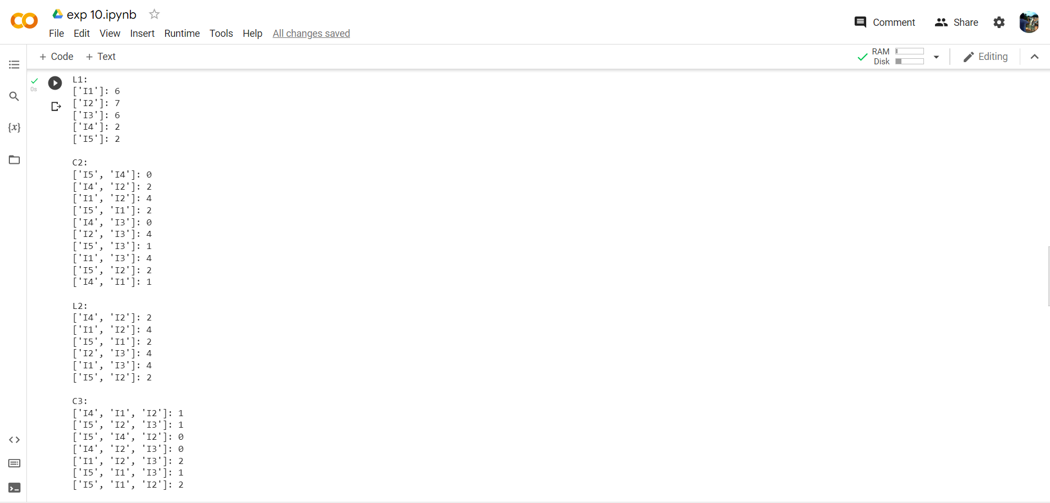

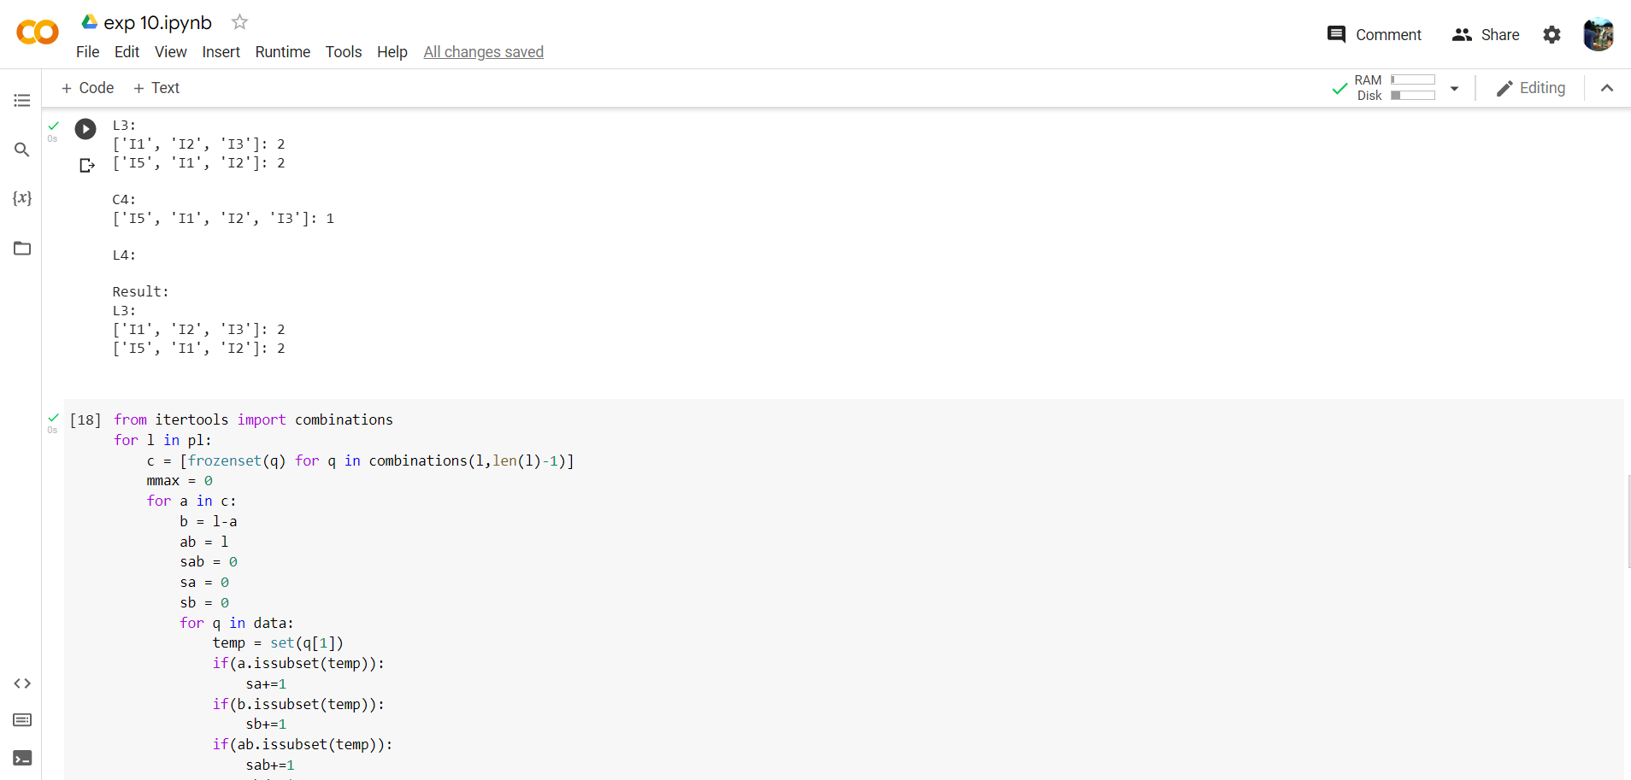

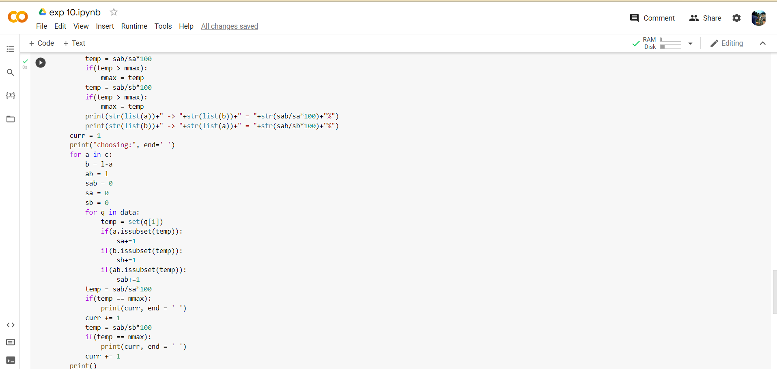

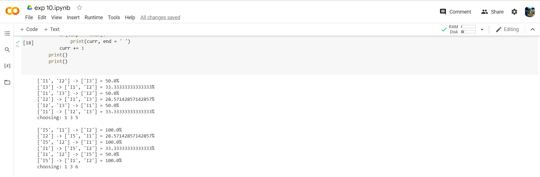

1. **Learning outcomes (What I have learnt):**

* Understood the concept of Association Rule Mining.
* Learnt how to find the Association rule for the Subset.
* Learnt the concept of Apriori.
* Completed the Worksheet Successfully.